The Odyssey
By Homer
The Suitors

Still in his disguise as an old man, 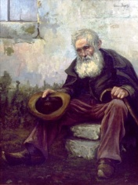 Odysseus enters his home. The first to talk to him is the haughty (arrogant) suitor, Antinous. He shouted, “God! What evil brought this pest to us? Why are you here at our table begging for food? This food is not ours to share with you!”
Odysseus answers, “Too bad you have more looks than heart. You sit here fat from other’s meat and cannot bring yourself to give one piece of bread to me!”
Antinous grew angry, “You think you can get away with speaking to me like that? No way!”
He threw a stool at Odysseus’ back. Odysseus just shook his head and continued to walk and drop his bag against the door. Then he turned, facing the crowd of men he said,
“One word only, there is no pain and no feelings of pain when a man is hit for defending his own cattle and possessions. On the other hand, Antinous hit me for being hungry! How many men have crossed oceans because of hunger? If the Furies (female spirits who avenge unpunished crimes) 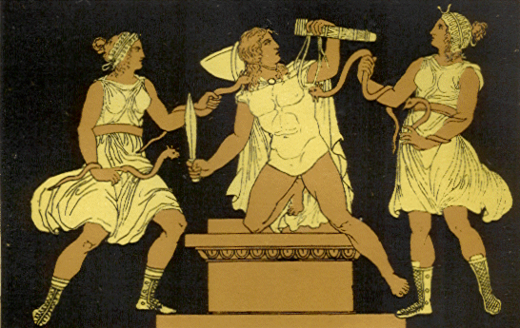 punish Antinous for this crime he committed, let it be death before he is able to marry!”
Antinous responded, “Enough. Eat and be quiet, unless you want these men to stretch your body until it breaks!”
Now the rest of the men were scared, and one of them spoke, “How dare you hit this poor old man for hunger! Imagine if he were a god in disguise!” Antinous just shrugged.
Telemachus watched the entire thing, not moving a muscle. Inside he was furious, but did nothing like his father told him to.
In a room above, Penelope 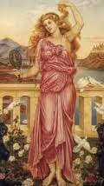 heard what happened to the old man, and said, “I wish Apollo 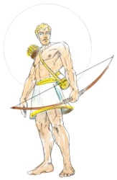would hit you with his bowshot, Antinous !” And Eurynome, 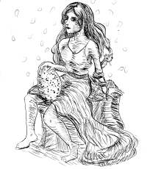 Penelope’s housekeeper replied, “And only Antinous? I pray that all of those men would not live another day!”
“No, here the old man came begging for food, and all of the other men gave him pieces of bread to fill his bag, except Antinous. His heart is black, and he threw a stool at the man instead. Please send the old man to me, so I can greet him and question him. Maybe Odysseus knows him!”

