The Odyssey
Book 2
by Homer
Twenty years later….
Odysseus finishes telling his story to the Phaeacians. He returns home by ship 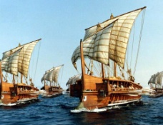 and speaks to Athena (goddess of Knowledge). 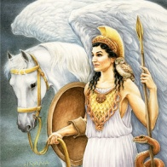 She tells him of the situation at home. Many men think Odysseus is dead and tries to marry his wife, Penelope. 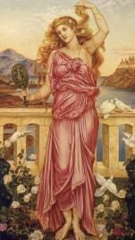 The men also plan to kill Telemachus, Odysseus’ son before he inherits the land. Athena gives Odysseus a disguise as a poor old man, 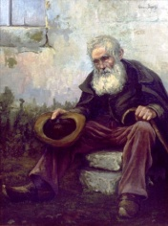 so he can enter his village. He immediately goes to see Eumaeus, a pig-herder. 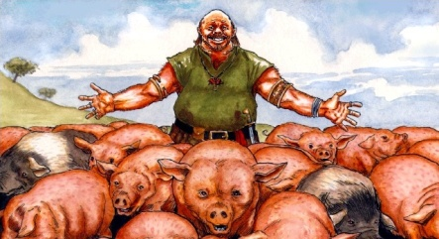
As they eat breakfast, Odysseus’ son, Telemachus 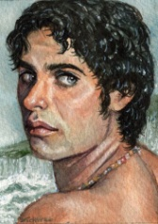comes by, and Athena appears to only Odysseus . She signals him to walk with her across the yard, and she says to him,
“Odysseus, tell your son who you really are and plan together how to destroy the men who are trying to take your land and wife, Penelope.”
Just then, Athena tapped Odysseus with her golden wand 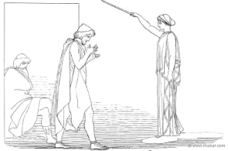 and he transformed into a young man with fresh cloaks. 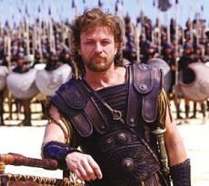 Telemachus, who did not see Athena, watched in amazement how his father transformed into the young man Odysseus once was. In shock, Telemachus asked Odysseus if he was a God, and Odysseus told him he was his father….the one who missed out on his son’s childhood. Odysseus then began to cry and embraced his son.
Only Telemachus did not believe him. He accused Odysseus of lying, and claimed that only Gods can transform the way he just did. Odysseus explained to Telemachus that it was Athena who changed him. They then hugged each other 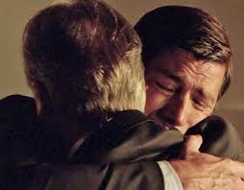. Telemachus asked his father how he came to Ithaca (home), and who brought him.
Odysseus told Telemachus of the voyage with the Pheaecians, and how they gave him gold and other gifts, which were all kept safe in a cave by the Gods. He told his son how Athena transformed him into an old man, and how they both must kill the men who are trying to marry Penelope and take the land.
Telemachus responded by asking his father how two men can can defeat 52 men from Dulichium with 6 of their armorers; 24 men from Same; 20 from Zacynthus; 12 from Ithaca, our home; and a pair of handymen. He asked his father to rethink this attempt to win back his land and his wife.
Odysseus answered with, “ The help of Zeus 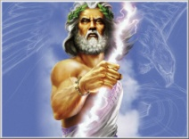 and Athena will guide us.”
Telemachus told his father not to depend upon the Gods for help because they have other problems to deal with from all over the world.
Odyessues continues, “ Zeus and Athena will be there when we need them most. Your job is to talk with the suitors (men). The pig-herder will walk me down a trail 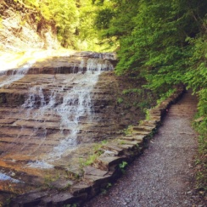 and I will be disguised as an old man. If they make fun of my age, Do not get angry; just tell them patiently to stop their joking. Athena will let me know when I should signal you, and at that point take all of our weapons and armor, and lances 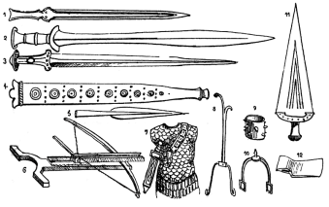 that belong to the suitors and store them in our vaulted room. 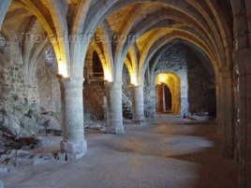 When the suitors ask for their armor, you tell them that you wanted to move them away from the smoke in the room. Tell them also, that if they begin to fight because they are drunk, there will be no weapons to kill each other with. After you are finished with them, put aside 2 broadswords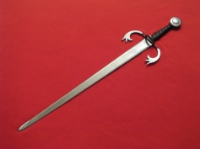 and 2 spears 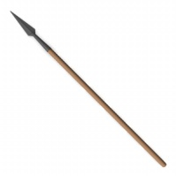for our own use with 2 oxhide shields 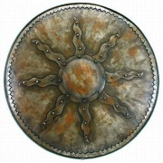nearby. Zeus and Athena will distract them while you do this. Now this is important….do not tell anyone I am here; not a single slave, Laertes, Penelope, or even the pig-herder. You and I alone must learn how the women are corrupted and where to find good men to fight with us, along with the shirkers (find definition) who do not take you seriously.

