The Odyssey
By Homer
“Scylla and Charybdis”
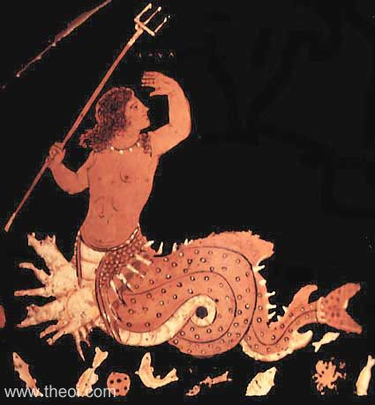 and 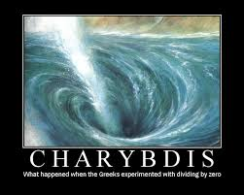

Lines 756-765 (Odysseus speaking)
As we sailed on and the island disappeared, we saw smoke 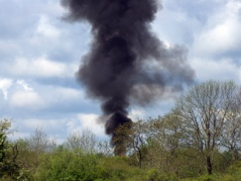 and white water, with the sound of waves.
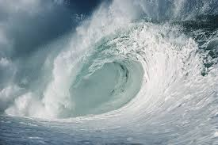 The men heard a sound that terrified them. The men lost their oars and the ship lost control. 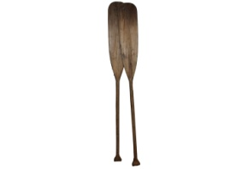I walked back and forth from the back of the ship to the front. I then spoke to my men.

Lines 766-781
Friends, we have already been in danger before this….is it more fearsome than when the Cyclops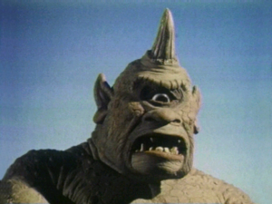 trapped us in his cave? How powerful was he?! I remained calm, though and found a way out of that danger! Keep your heads up friends!
Let us get back our oars, 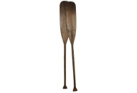 and work hard to get out of these waves
Zeus, help us pull away before we drown. YOU, (talking to one man) listen to what I say! Keep the ship out of the waves that crash down on the shore or we will all drown!
Lines 783-881
My crew did nothing. And as we moved on towards Scylla, I said no more. My men could do nothing about it anyway. Earlier, Circe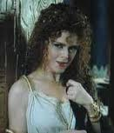 had told me to not use my armor, 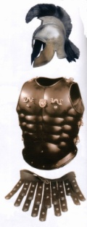 but I tied it on anyway. I grabbed two heavy spears.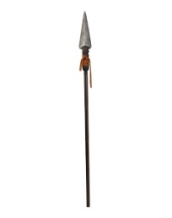I tried to look for her, but I could not see her anywhere. All of a sudden, Scylla is on one side of our ship, and Charybdis is on the other. She vomited boiling sea water 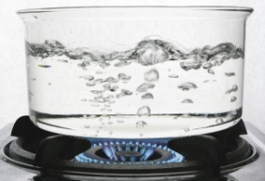 up onto our ship, and saw a large violent whirlpool begin all around us. 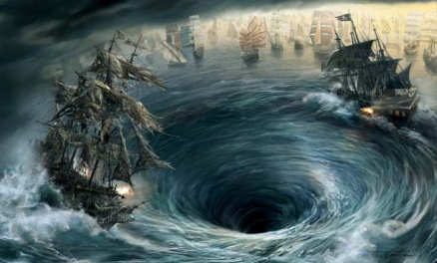

Lines 810-827
As Charybdis began her whirlpool, Scylla made her strike. She took six of my men. 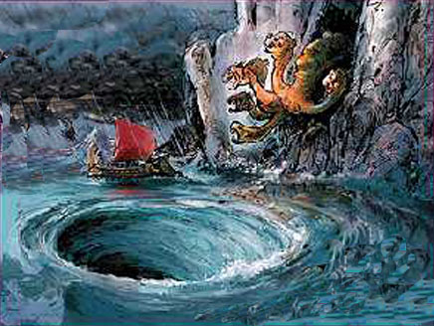 Scylla ate my men as they shrieked, and she reached for me.
I felt horrible for my men as I saw them ripped to pieces. We continued to row on, and finally, Scylla and Charybdis were far behind us.

