The Odyssey
By Homer
“The Challenge”

The suitors urged Penelope 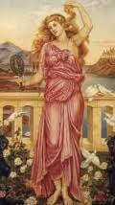 to choose a husband to marry, so Penelope created
a challenge. She told them that she will marry the one man who can string Odysseus’
bow 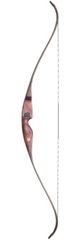and shoot an arrow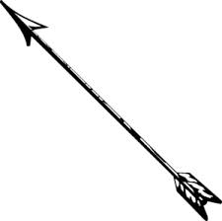 through 12 axhandle sockets. 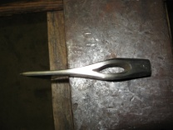

After all of the suitors tried and failed, Odysseus 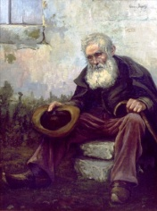 still disguised as an old man, asked for a try. The other suitors commented on the way he handled the bow, 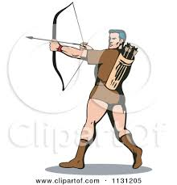which of course, they did not know belonged to him in the first place. They said, “Look how he handles that bow! He must have one like it at home!”

Odysseus set the arrow onto the string (nocked) and pulled back. He released, and the arrow zoomed through the air through every socket 

