The Odyssey
By Homer
“Penelope’s Test”

Penelope tests Odysseus to prove he is really her husband. Home at last, Odysseus 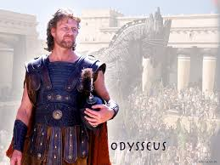 was being bathed by Eurynome. She rubbed him with golden oil and clothed again in a fresh cloak and tunic. Athena 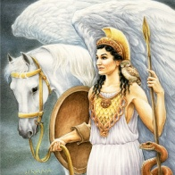 gave him more beauty. He was taller and stronger than before. Odysseus sat across from his wife, Penelope and said, “Strange woman, you are colder and harder than what I remember. How can you sit there and look at your husband as if he was here the whole time? I have been gone for 20 years!”
She answered, “If you are Odysseus, as you say you are, I remember how you left Ithaca for Troy….but all the same.
Make up his bed for him, Eurycleia. Place his bed outside the bedroom that my husband built with his own hands.”
Odysseus became angry at this. “How dare you move my bed? No builder has the skill for that-unless a God came down to move it himself. I build that bed myself so that no man can move it. That is our secret. An old trunk of olive 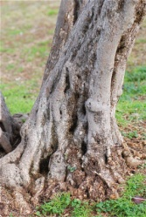 stands here, which I built our room around!” 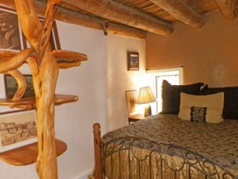
As she heard him say this, tears ran down her cheeks and she ran towards him, wrapped her arms around him and kissed him. 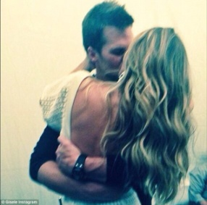
“Please forgive me Odysseus! No other man has seen my bed other than my slave, Actoris. My heart beats again knowing that I am yours.”

The End

