The Odyssey
By Homer
Penelope

In the evening, Penelope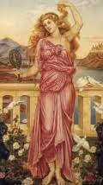 questions the old man. 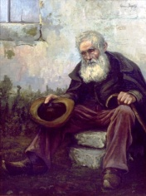

Penelope asks, “Old friend, who are you? Where do you come from? Of what nation are your parents from?”
The old man (Odysseus) replies, “My lady, I have heard about you from across the world, like some sweet honor of some god-fearing King, who rules with justice over the strong. Let me tell you of other things; not of my blood or my home. My heart is sore and I must not cry here in your house. One of your maids might say that I have become foolishly sentimental by drinking wine.”
Penelope answers, “My looks faded as soon as the Achaeans crossed the sea to Troy with Odysseus, 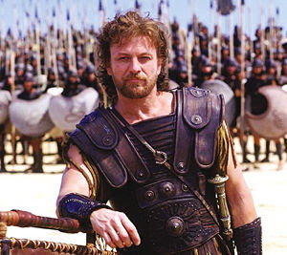 my husband. If only he came back, I would be happy once more! Instead heaven sent me many suitors (men who want to marry me) who have taken over my house against my wish. What can I do while I wait for my husband to return? I use tricks to waste time . I had thought of setting up weaving on my loom. 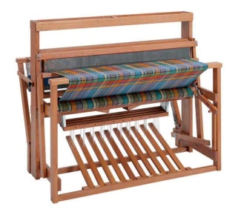I told my suitors, ‘Men, my husband is dead. Let me finish my weaving before I marry. I must make a blanket 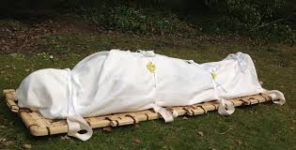to cover him in the after-life.’ The men agreed, and for 3 years I wove 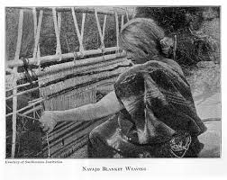everyday. Every night, I unwove it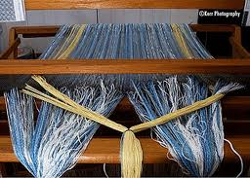. One night, the suitors found me, and I had no choice but to finish it. I cannot avoid marriage any longer. My parents are urging me, and my son Telemachus is tired of the men using up his food and home. Please, tell me your story now. I have told you mine. “

The old man speaks, “Odysseus is now on his way home. I swear it on Zeus, and the moon that Odysseus is to return home to you.

