The Odyssey
By Homer
“Odysseus’ Revenge”

Now dropping his disguise, Odysseus stood in the doorway as the proud King and fighter of his kingdom. 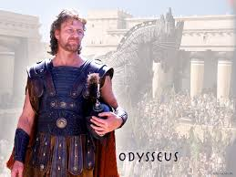 He said to the suitors, “So much for that. Now watch me hit a target no man has hit before. Help me, Apollo.”
He held the arrow in his hand and again and this time aimed for Antinous 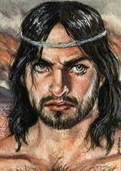as he leaned forward to take a sip from his beautiful golden wine cup. 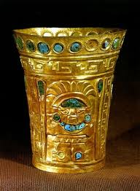 Not knowing what was happening, he took a sip from the cup, and as he did this, Odysseus’ arrow hit him in the throat and pierced him all the way to the feathers. 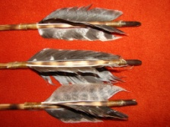 Antinous fell back, letting the wine cup fall from his hands. Blood flowed from his nostrils 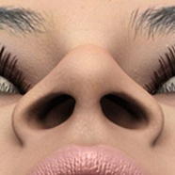. The other suitors got up in shock and ran towards down the hall looking for their armor 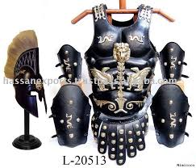, but it was nowhere to be found. All they could do was yell at Odysseus. “Fool! That was your last shot! You will pay for shooting at a man! You killed the best in Ithaca.” They all believed it was a wild arrow or a mistake. Fools.
Odysseus answered, “You yellow dogs! 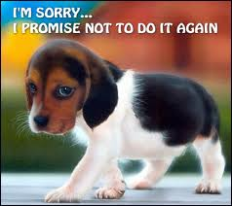You thought I would never return home. You took my house and tried to marry my wife thinking I would die! Contempt is all you have for the Gods! Your last hour has come! You will all die tonight!”
At this moment, all of the men became sick and green with fear. 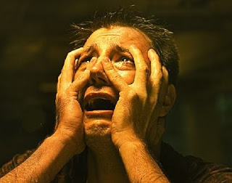 Eurymachus was the only one who could speak, “If you are Odysseus, all that you say these men have done are true. But Antinous, our leader lies dead here. 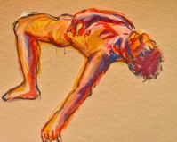 He caused all of this. He wanted power and tried to trap your son 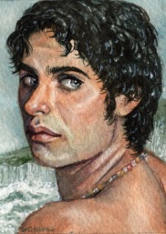. Spare us, and we will pay you back everything we have taken, plus more, like gifts of gold and bronze 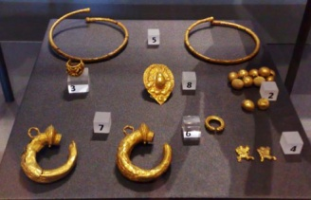 and cattle. 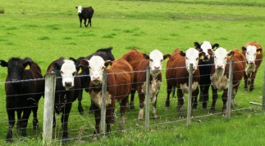 We are sorry, and we do not blame you for your anger.”
Odysseus looked at them and said, “Not for all of the treasure in the land will I say peace. There will be killing here until the score is paid. You forced yourselves upon this house. Fight your way out or run if you think you can.”
Eurymachus turned to his friends and said, “The man is going to try to kill us. I say we fight, and remember the joy of it! Swords out! 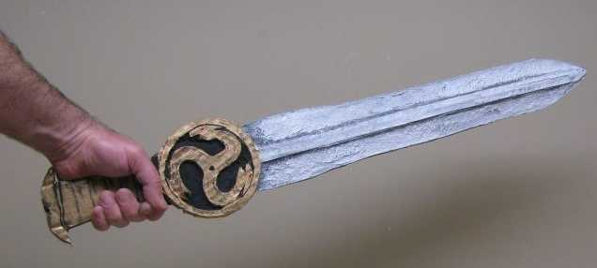 Turn the tables 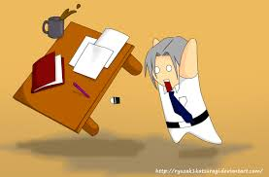to protect us from the arrows. Everyone rush at him!”
Eurymachus flung himself toward Odysseus 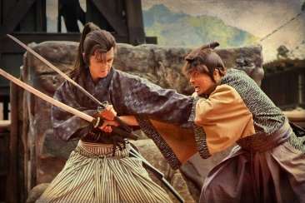, but he let an arrow fly at the same moment which hit Eurymachus in the chest. Now Amphinomus came running at Odysseus, but Telemachus came from behind with a spear 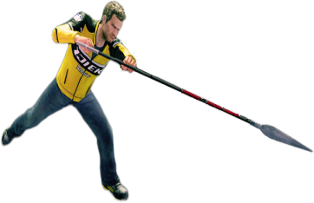and hit him between the shoulders. Telemachus left the spear and ran to his father’s side. “Father, let me bring you a shield and spear, a helmet and equipment.”
Odysseus answered, “Run then. I will hold them off with my bow and arrows until you return.”
Telemachus ran to get all the of the weapons and equipment he can handle. While he was gone, Odysseus shot arrow after arrow until he had none left. He held up his shield, layed his bow down and began to fight. With the help of Athena 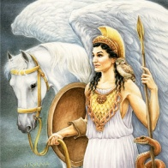, Odysseus, Telemachus, and Eumaeus fought the suitors until all were dead.
As Odysseus looked around, he saw the crowd of suitors had fallen. Like a fisherman’s catch when he empties his net, 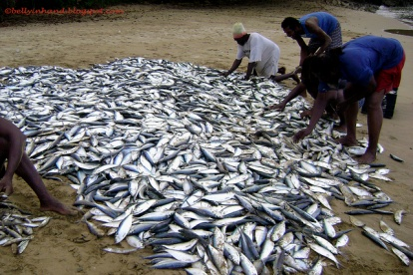 the men lay on top of each other 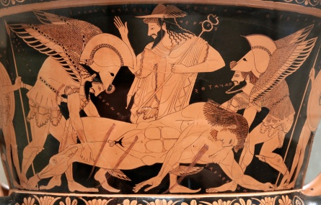 as they twitched for the last time.

