The Odyssey
by Homer
“The Cattle of the Sun God”
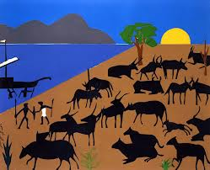

Directions: Below I have begun to summarize “The Cattle of the Sun God”. Please use the text book to fill in the blanks using your own words, using the images to guide you.

Lines 828-837
In the evening, right after the sun had set, 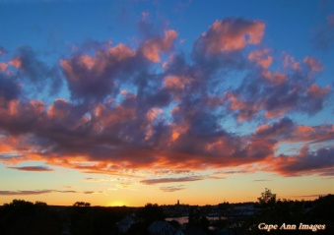 a giant wind blew from heaven, and the clouds driven by Zeus 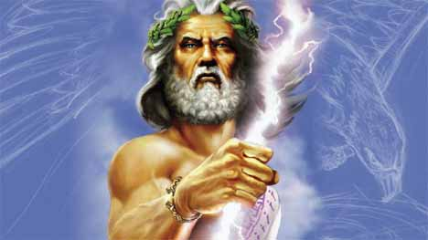 covered the land and sea for a stormy night. Just as the sun came up, we dragged our ship to a grotto (sea cave) where nymphs 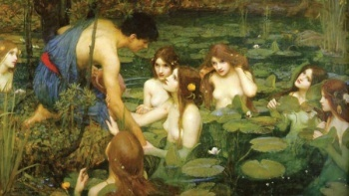 sat on top of rocks and sanded floors. I spoke to my crew:
Lines 842-860
“Dear companions, the food and drink we have stored is for us to take. The cattle here 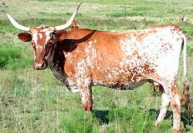 ____________________________________________________________. The God whom these cattle belong to is fierce; Helios (Apollo), 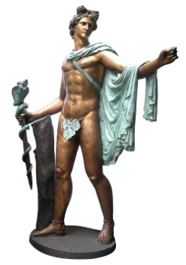and he sees everything.
My men agreed to my wishes, but by now, a month went by onshore. As long as the bread 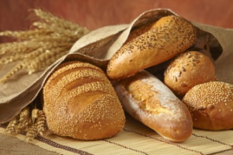 and wine 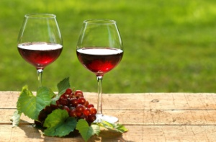 remained

______________________________________________________________________________________________. In the end though, when all of the barley 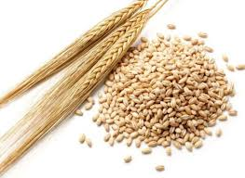 in the ship was gone, _

_________________________________________________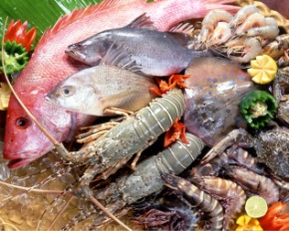 and 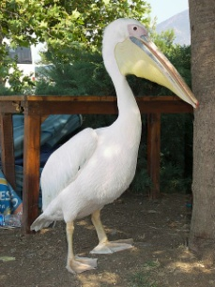

______________________________________________. The storms continued, so one day, I alone prayed 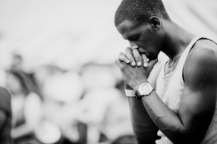 to the Gods for _________________________ that something would save us. I traveled across the island and came to a sheltered spot. I washed my hands there and begged to the Gods of Mount Olympus.
In return, ________________________________________________________________________.
Back on the shore, Eurylochus made his crafty plea.
Lines 861-894
Eurylochus speaks: “Comrades, we have been through too much to starve now. Come with me and we will _______________________________________________________ for the Gods. When we return to Ithaca, we will ___________________________________________”. 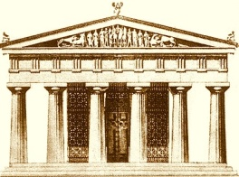 All of the men agreed. They killed one of the cattle and sacrificed it. 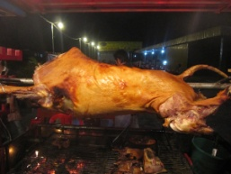
Lines 895-914
Just then, I woke up and ran back to my men. In horror, I saw my men
___________________________________________________________ and cried:
“ Oh father Zeus! __________________________________________________!”
Lampetia (a nymph) 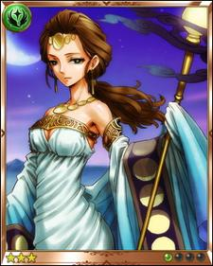 ran and told Helios, the Sun God. He then cried to Zeus:
“ Father Zeus! Punish Odysseus and his men! They have killed one of my cattle!”
Zeus 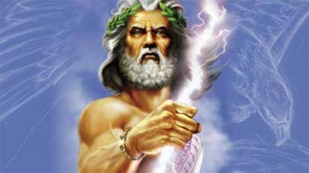 then said, “_________________________________________
_________________________________________________________________,”
Lines 920-955
When I reached the ship, I talked to each of my men. All of the cattle of Helios were dead. The Gods
then _____________________________________________________________________________.
For six days, my crew ate the beef from Helios’ cattle. 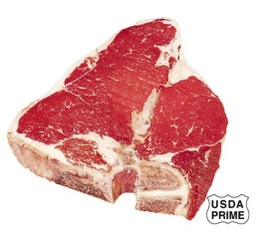 After those six days, we sailed on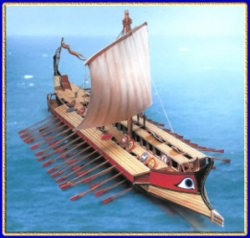 and we were soon in the middle of the Ocean. No land could be seen. That is when Zeus brought us a storm overhead. 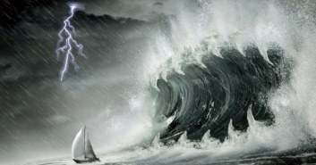 Then

_________________________________________________________________________________. Another wave came and hit one of my men, which killed him. Zeus threw a bolt of lightning 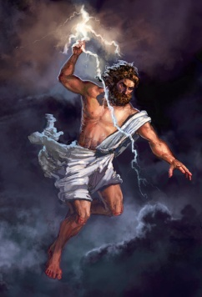 at the ship and ______________________________________________________
_________________________________________________________________________________.
Lines 955-980
Zeus had punished my men. They will never return home. I used pieces of the boat to build a raft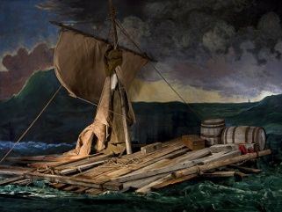 and I _______________________________________________________. The storm died down, but the Southwest wind blew me north towards Charybdis. 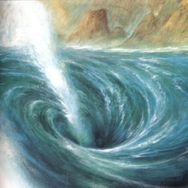 All night
I tried to avoid both Charybdis and Scylla. I was thrown off my raft and grabbed a big fig tree. 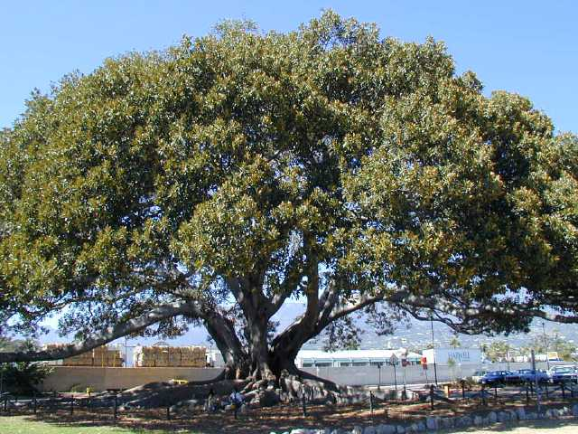 I was hanging over Charybdis until my raft came back up to the surface. I
then ______________________________________________________________________________.
Lines 985-995
I finally let go of the fig tree, and plunged onto the raft. I would have never
been able to paddle past Scylla if the Gods had not helped me. For nine days, I _________________

____________________________________________________________________________________ to Ogygia Isle. This is the Island where Calypso 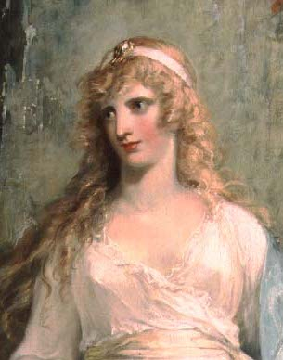 lives, and there she ______________

____________________________________.

But why retell the story again? It took all night to tell, and I am tired of the repetition.

The End

