The Odyssey
By Homer
Argus

As Odysseus 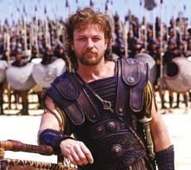 (in the disguise of an old man) 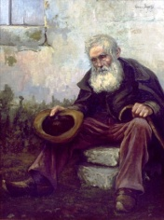walks with Eumaeus 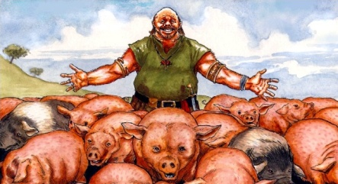 into town, and he sees his old dog, Argus 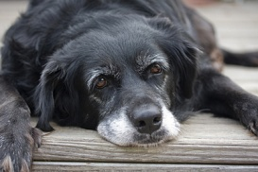waiting for him. The last time Odysseus has seen Argus, he was a puppy. While Odysseus was gone, the young men of town took him on hunts 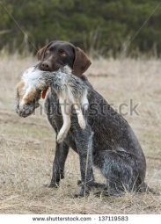 for rabbits and deer, but now he has grown old and lonely. Argus heard the voice of his master, and slowly tried to stand up, but Odysseus noticed him lying there on by the gate as well and sadly looked away with a tear. He said to Eumaeus, “I cannot believe they leave that old dog lying there like that. He would have been a fine dog in his youth.”
Eumaeus replied (not knowing it was Odysseus he was speaking to), “A hunter named Odysseus owned him. The man is dead now in some far off place. If you could see how strong this dog used to be when Odysseus left him to go to Troy, you’d see him fast and strong. 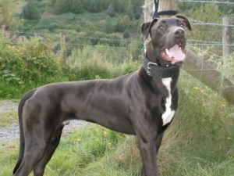 The women slaves will not take care of him since his owner has gone.”
As Eumaeus walked towards the megaron (great house with a fireplace), Argus slipped away into death as he looked upon Odysseus for the last time.

