Part 1: Antigone and Ismene
Antigone tells her sister, Ismene that the King (Creon) 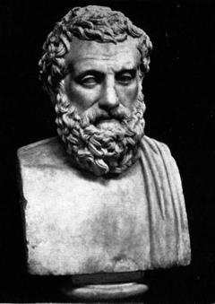 has ordered that their brother, Polynices never be buried.

(Both of their brothers, Polynices and
Eteocles have died, but because Polynices is a

traitor, he shall not be buried by orders of Creon.)

Antigone asks her sister to help bury Polynices because if he is not buried, he will never be able to properly rest in the underworld.
Ismene does not want to help her because if anyone was to find out who buried Polynices is buried, it could mean death to that person. Antigone gets angry with her because
Polynices is their brother. To antigone, Family is above Law. Ismene promises to keep her secret of the plan to bury her brother Polyinces. At this point, Antigone does not care who knows.

